Práctica 5 CPLP

**Objetivo: Interpretar cómo se organiza la memoria de datos durante la ejecución de un programa con llamados a subrutinas**.

# Ejercicio 1:

**Explique claramente cual es la utilidad del registro de activación y que representan cada una de sus partes.(Basado en el modelo debajo detallado)**

| Registro de activación | Explicación |
| --- | --- |
| Head (prog principal) | Current: Dirección base del registro de activación actual.  Free: Próxima dirección libre en la pila. |
| Pto retorno | Instrucción a la que se vuelve después de ejecutar una subrutina. |
| EE (enlace estático) | Apunta al registro de activación de la rutina que lo contiene estaticamente. |
| ED (enlace dinámico) | Apunta a la dirección base del registro de activación de la rutina que lo llama. |
| Variables… | Variables definidas dentro de la rutina |
| … |  |
| Parámetros… | Variables a ser usadas por la siguiente rutina. |
| … |  |
| Procedimientos… | Procedimientos definidos dentro de la unidad. |
| … |  |
| Funciones… | Funciones definidas dentro de la unidad. |
| … |  |
| Valor de retorno | Valor de retorno de una subrutina llamada dentro de la unidad, ya que cuando termina la rutina se desaloja, se pone aca. |

La utilidad del registro es guardar de manera estructurada en memoria toda la información necesaria para la ejecución de una unidad de código.

Ejercicio 2: Dado el siguiente programa escrito en Pascal-like, continuar la realización de las pilas de ejecución hasta finalizar las mismas.

a) Siguiendo la cadena estática b) Siguiendo la cadena dinámica

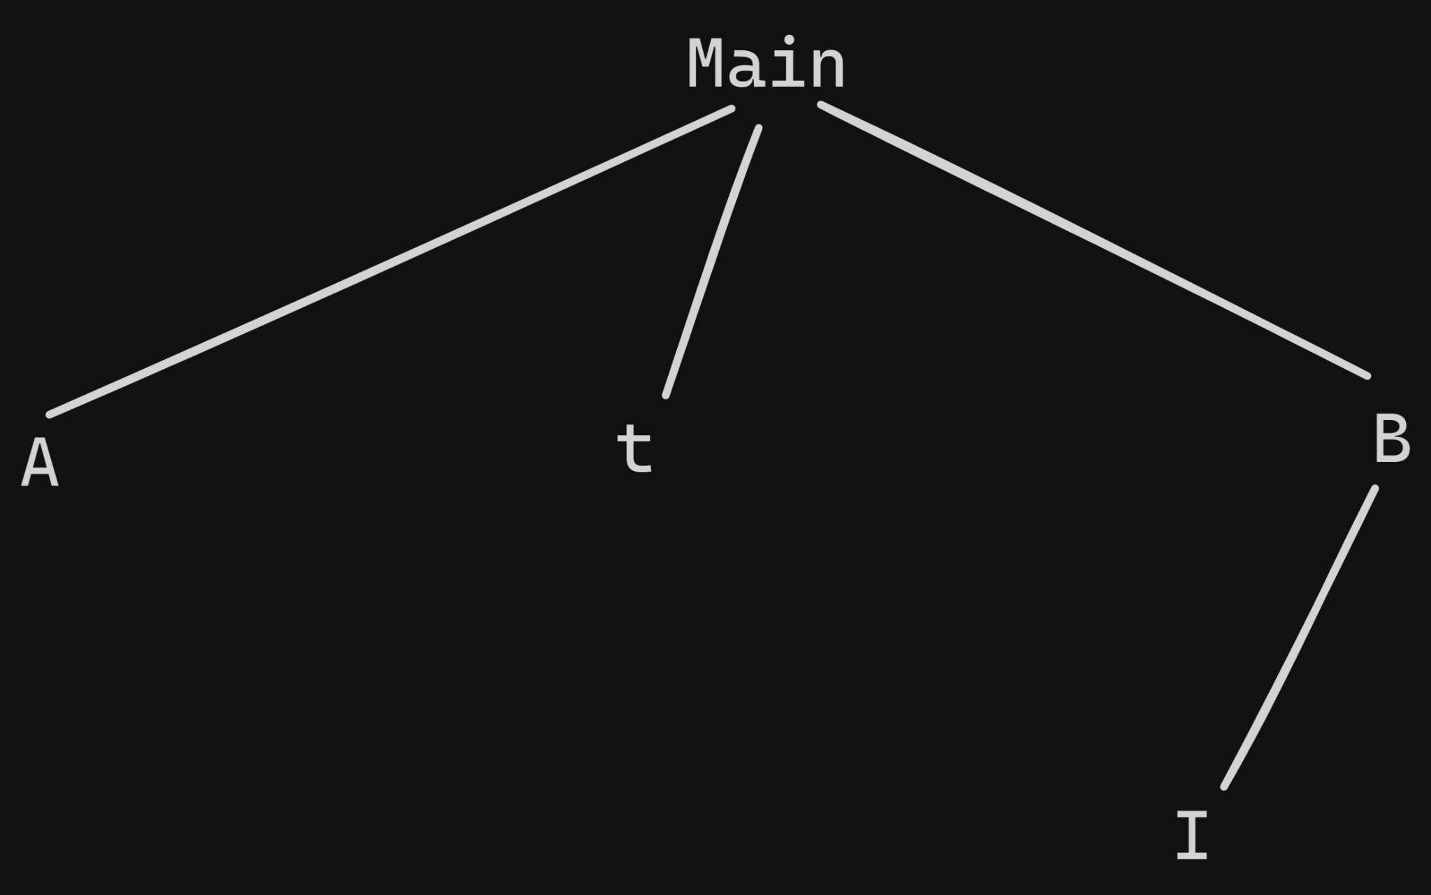

| 1. Program Main 2. Var a: array[1..10] of integer; 3. x,y,z:integer 4. Procedure A () 5. var y,t: integer; 6. begin 7. a(1):= a(1)+1;z:=z+1; 8. t:=1; y:=2; 9. B(); a(y):=a(y)+3; y:=y+1; 10. If z=11 Then Begin 11. a(z-1):=a(z-2) + 3; 12. z:=z-4; 13. a(z-y):=a(z) – a(y) + 5; 14. End; 15. end; 16. Function t():integer 17. begin 18. y:=y+1; z:=z-6; 19. return(y+x); 20. end; 21. Procedure B() 22. var d:integer; 23. Procedure I () 24. begin 25. x:=0; x:=x+6; 26. end; 27. begin 28. x:=x+t; d:=0; 29. while x>d do begin 30. I(); x:=x-1; 31. d:=d + 2; 32. end; 33. end; 34. begin 35. For x:=1 To 10 do a(x):=x; 36. x:=5; y:=1; z:=10; 37. A(); 38. For x:=1 To 10 do write(a(x),x); 39. end. | | Cadena estática | | | --- | --- | |  | **\*\*\* Reg Activ Main** | | *1 | Pto retorno | |  | A(1)= 1-> 2 | |  | A(2)= 2 -> 5 | |  | A(3)= 3 | |  | A(4)= 4 | |  | A(5)= 5 | |  | A(6)= 6 | |  | A(7)= 7 | |  | A(8)= 8 | |  | A(9)= 9 | |  | A(10)= 10 | |  | X= 1..10 -> 5 -> 13 -> 0 -> 6 -> 5 -> 0 -> 6 ->5 -> 0 -> 6 ->5 -> 1..10 | |  | Y= 1 –> 2 | |  | Z=10 –> 11 –> 5 | |  | Procedure A | |  | Function T | |  | Procedure B | |  | **VR . . . . . . . .** | | **\*2** | **\*\*\*Reg Activ A** | |  | Pto Retorno | |  | **EE (*1)** | |  | ED (*1) | |  | **Y = 2 -> 3** | |  | T = 1 | |  | VR . . . . . . . . | | *3 | *** Reg Activ B | |  | **Pto Retorno** | |  | **EE(*1)** | |  | **ED(*2)** | |  | D = 0 -> 2 -> 4 -> 6 | |  | Procedure I | |  | **VR . . 8 . .** | | *4 | **\*\*\* Reg Activ t** | |  | Pto retorno | |  | EE(*1) | |  | ED(*3) | |  | **VR** | |  | ---- | | *5 | **\*\*\* Reg Activ I** | |  | Pto retorno | |  | EE(*3) | |  | ED(*3) | |  | **VR** | |  | ---- | | *5 | **\*\*\* Reg Activ I** | |  | Pto retorno | |  | EE(*3) | |  | ED(*3) | |  | **VR** | |  | ---- | | *5 | **\*\*\* Reg Activ I** | |  | Pto retorno | |  | EE(*3) | |  | ED(*3) | |  | **VR** | |  | ---- |   Imprime:  2, 1  5,2  3,3  4,4  5,5  6,6  7,7  8,8  9,9  10,10   | Cadena dinamica | | | --- | --- | |  | **\*\*\* Reg Activ Main** | | *1 | Pto retorno | |  | A(1)= 1-> 2 | |  | A(2)= 2 -> 5 | |  | A(3)= 3 | |  | A(4)= 4 -> 9 | |  | A(5)= 5 | |  | A(6)= 6 | |  | A(7)= 7 | |  | A(8)= 8 | |  | A(9)= 9 | |  | A(10)= 10 -> 12 | |  | X= 1..10 -> 5 -> 6 -> 0 -> 6 -> 5 ->0 -> 6 -> 5 ->0 -> 6 -> 5 -> 1…10 | |  | Y= 1 –> 2 | |  | Z=10 –> 11 -> 7 | |  | Procedure A | |  | Function T | |  | Procedure B | |  | **VR . . . . . . . .** | | **\*2** | **\*\*\*Reg Activ A** | |  | Pto Retorno | |  | **EE (*1)** | |  | **ED (*1)** | |  | Y = 2 -> 3 | |  | T = 1 | |  | VR . . . . . . . . | | *3 | *** Reg Activ B | |  | **Pto Retorno** | |  | **EE(*1)** | |  | **ED(*2)** | |  | D = 0 -> 2 -> 4 -> 6 | |  | Procedure I | |  | **VR . . . .** | | *4 | **\*\*\* Reg activ I** | |  | **Pto retorno** | |  | **EE(*3)** | |  | **ED(*3)** | |  | **VR** | |  | **--** | |  |  |   Imprime  2, 1  5,2  3,3  9,4  5,5  6,6  7,7  8,8  9,9  12,10 |
| --- | --- | --- | --- | --- | --- | --- | --- | --- | --- | --- | --- | --- | --- | --- | --- | --- | --- | --- | --- | --- | --- | --- | --- | --- | --- | --- | --- | --- | --- | --- | --- | --- | --- | --- | --- | --- | --- | --- | --- | --- | --- | --- | --- | --- | --- | --- | --- | --- | --- | --- | --- | --- | --- | --- | --- | --- | --- | --- | --- | --- | --- | --- | --- | --- | --- | --- | --- | --- | --- | --- | --- | --- | --- | --- | --- | --- | --- | --- | --- | --- | --- | --- | --- | --- | --- | --- | --- | --- | --- | --- | --- | --- | --- | --- | --- | --- | --- | --- | --- | --- | --- | --- | --- | --- | --- | --- | --- | --- | --- | --- | --- | --- | --- | --- | --- | --- | --- | --- | --- | --- | --- | --- | --- | --- | --- | --- | --- | --- | --- | --- | --- | --- | --- | --- | --- | --- | --- | --- | --- | --- | --- | --- | --- | --- | --- | --- | --- | --- | --- | --- | --- | --- | --- | --- | --- | --- | --- | --- | --- | --- | --- | --- | --- | --- | --- | --- | --- | --- | --- | --- | --- | --- | --- | --- | --- | --- | --- | --- | --- | --- | --- | --- | --- | --- | --- | --- | --- | --- | --- | --- | --- | --- | --- | --- | --- | --- | --- | --- | --- |

# Ejercicio 3:

**Sea el siguiente programa escrito en Pascal-like. Realice la pila de ejecución**

**a) Siguiendo la cadena estática**

**b) Siguiendo la cadena dinámica**

| 1. PROGRAM P1; 2. var 3. a:integer; 4. b:char; 5. c: array[1..10] of integer 6. Procedure PP1; 7. var 8. a:char; 9. p:integer; 10. Function x: integer; 11. var 12. z:integer; 13. begin 14. a:="j"; 15. z=-1; 16. return z; 17. end; 18. Begin 19. p:=x; 20. write(a); 21. p:=x+3; 22. c[p]=8; 23. p:=x+2; 24. c[p]=x; 25. end; 26. Procedure x; 27. var 28. b:char; 29. Procedure PP2; 30. Begin 31. write("para qué estoy aquí?"); 32. end; 33. Begin 34. a:=1; 35. c[a]:=4; 36. b:="a"; 37. write(concat(c[1],b)); /*concat convierte a string los 38. parámetros, concatena y retorna un string;*/ 39. PP1(); 40. b:="b"; 41. write(concat(c[5],b)); /*concat convierte a string los 42. parámetros, concatena y retorna un string;*/ 43. End; 44. BEGIN 45. a:=3; 46. b:="c"; 47. for a:=3 to 10 do 48. begin 49. c[a]:=2*a; 50. end; 51. x; 52. write(b); 53. write(a); 54. for a:=1 to 10 do 55. write(c[a]-3); 56. END. | | Cadena estática | | | --- | --- | | *1 | **\*\*\* Reg activ P1** | |  | P.R | |  | a = 3-> 3..10 -> 1 -> 1..10 | |  | b = “c” | |  | c(1) = 4 -> -1 | |  | c(2) = 8 | |  | c(3) = 6 | |  | c(4) = 8 | |  | c(5) = 10 | |  | c(6) = 12 | |  | c(7) = 14 | |  | c(8) = 16 | |  | c(9) = 18 | |  | c(10) = 20 | |  | Procedure PP1 | |  | Procedure X | |  | **VR** | | *2 | **\*\*\* Reg activ x** | |  | P.R | |  | EE(*1) | |  | ED(*1) | |  | b = “a” -> “b” | |  | Procedure PP2 | |  | VR | | *3 | **\*\*\* Reg activ PP1** | |  | P.R | |  | EE(*1) | |  | ED(*2) | |  | a = “j” -> “j” -> “j” -> “j” | |  | p = -1 -> 2 -> 1 | |  | Function x | |  | V.R -1 -> -1 -> -1 -> -1 | | *4 | **\*\*\* Reg activ X** | |  | P.R | |  | EE(*3) | |  | ED(*3) | |  | z = -1 | |  | V.R | | *5 | **\*\*\* Reg activ X** | |  | P.R | |  | EE(*3) | |  | ED(*3) | |  | z = -1 | |  | V.R | | *6 | **\*\*\* Reg activ X** | |  | P.R | |  | EE(*3) | |  | ED(*3) | |  | z = -1 | |  | V.R | | *7 | **\*\*\* Reg activ X** | |  | P.R | |  | EE(*3) | |  | ED(*3) | |  | z = -1 | |  | V.R | |  |  |   Imprime:  4a  j  10b  c  1  -4  5  3  5  7  9  11  13  15  17   | Cadena dinámica (es igual q la estática) | | | --- | --- | | *1 | **\*\*\* Reg activ P1** | |  | P.R | |  | a = 3 -> 3..10 -> 1 -> 1..10 | |  | b = “c” | |  | c(1) = 4 -> -1 | |  | c(2) = 8 | |  | c(3) = 6 | |  | c(4) = 8 | |  | c(5) = 10 | |  | c(6) = 12 | |  | c(7) = 14 | |  | c(8) = 16 | |  | c(9) = 18 | |  | c(10) = 20 | |  | Procedure X | |  | Procedure PP1 | |  | V.R | | *2 | **Reg activ X** | |  | P.R | |  | EE(*1) | |  | ED(*1) | |  | b = “a” -> “b” | |  | **Procedure PP2** | |  | V.R | | *3 | **Reg activ PP1** | |  | P.R | |  | EE(*1) | |  | ED(*2) | |  | a = “j” -> “j” -> “j” -> “j” | |  | p = -1 -> 2 -> 1 | |  | Function x | |  | **V.R -1 -> -1 -> -1 -> -1** | | *4 | **Reg activ X** | |  | P.R | |  | EE(*3) | |  | ED(*3) | |  | z = -1 | |  | V.R | | *5 | **Reg activ X** | |  | P.R | |  | EE(*3) | |  | ED(*3) | |  | z = -1 | |  | **V.R** | | *6 | **Reg activ X** | |  | P.R | |  | EE(*3) | |  | ED(*3) | |  | z = -1 | |  | V.R | | *7 | **Reg activ X** | |  | P.R | |  | EE(*3) | |  | ED(*3) | |  | z = -1 | |  | V.R |   Imprime  4a  j  10a  c  1  -4  5  3  5  7  9  11  13 |
| --- | --- | --- | --- | --- | --- | --- | --- | --- | --- | --- | --- | --- | --- | --- | --- | --- | --- | --- | --- | --- | --- | --- | --- | --- | --- | --- | --- | --- | --- | --- | --- | --- | --- | --- | --- | --- | --- | --- | --- | --- | --- | --- | --- | --- | --- | --- | --- | --- | --- | --- | --- | --- | --- | --- | --- | --- | --- | --- | --- | --- | --- | --- | --- | --- | --- | --- | --- | --- | --- | --- | --- | --- | --- | --- | --- | --- | --- | --- | --- | --- | --- | --- | --- | --- | --- | --- | --- | --- | --- | --- | --- | --- | --- | --- | --- | --- | --- | --- | --- | --- | --- | --- | --- | --- | --- | --- | --- | --- | --- | --- | --- | --- | --- | --- | --- | --- | --- | --- | --- | --- | --- | --- | --- | --- | --- | --- | --- | --- | --- | --- | --- | --- | --- | --- | --- | --- | --- | --- | --- | --- | --- | --- | --- | --- | --- | --- | --- | --- | --- | --- | --- | --- | --- | --- | --- | --- | --- | --- | --- | --- | --- | --- | --- | --- | --- | --- | --- | --- | --- | --- | --- | --- | --- | --- | --- | --- | --- | --- | --- | --- | --- | --- | --- | --- | --- | --- | --- | --- | --- | --- | --- | --- | --- | --- | --- | --- | --- | --- | --- | --- | --- | --- | --- | --- | --- | --- | --- | --- | --- | --- | --- | --- | --- | --- | --- | --- | --- | --- | --- | --- | --- | --- | --- | --- | --- | --- | --- | --- | --- | --- | --- |

# 